# Justice at Harvard: Rawls and Nozick

**Justice** is the principle that “equals ought to be treated equally, and unequals ought to be treated unequally.” Another way of saying this might be: in a perfectly just society, people get the rewards they deserve. People who are born with rich parents (or with good genes) do not benefit from these (undeserved) advantages; conversely, people who are born to poor parents (or with genes that leave them predisposed to disease) are not harmed by these undeserved initial disadvantages. Similarly, a just society does not make *unfair* discriminations based on things like religion, sexual orientation, race, or age. In this lecture, we’ll be taking a look at two of the most important theories of justice from the last 100 years: John Rawls’ defense of liberal egalitarianism and Robert Nozick’s defense of libertarianism. While you might not have heard of these thinkers, they’ve been very influential in shaping the way policy makers (liberal, moderate, and conservative) have thought over the last 40 years or so.

## John Rawls: “Justice as Fairness”

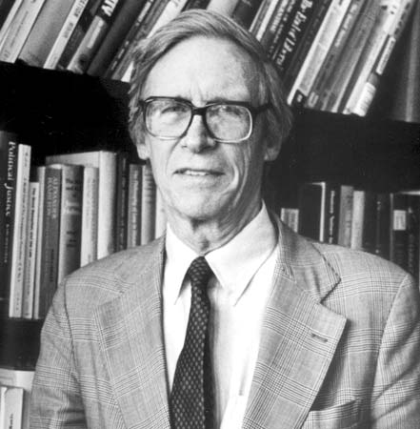**John Rawls** (1921 to 2002) is widely considered one of the most important ethical theorists of the past 200 years. His 1971 book *A Theory of Justice* offered one of the first modern systematic answers to the question “What should a just society look like?” The theory he defends (“justice as fairness”) is sometimes called **liberal egalitarianism.** In the course of the book, he introduces a number of key concepts that are now widely used in political theory: contract theory, hypothetical consent, the original position, the veil of ignorance, primary goods, the difference principle, the maxi-min principle, and reflective equilibrium. He is often cited by “center-left” politicians (such as Barack Obama or Bill Clinton) as a major influence.

Rawls’s basic thesis is as follows: **In a just society, goods and services should be distributed to maximize the position of the people who are worst off (such as the poor or sick). However, this must be accomplished *without* violating anyone’s basic rights to speech, assembly, religion, private property, or political participation, and without discriminating against anyone unfairly.** This thesis forms the basis of much modern “left liberal” political thought. Rawlsians generally favor a “mixed economy” in which there is both a substantial private market and large public (government) sector.

### Social Contract Theory, the Original Position, and Hypothetical Consent

Rawls’ argument in favor of liberal egalitarianism is one of the more famous philosophical arguments of the 20th century:

“Thus we are to imagine that those who engage in social cooperation choose together, in one joint act, the principles which are to assign basic rights and duties and to determine the division of social benefits. Men are to decide in advance how they are to regulate their claims against one another and what is to be the foundation charter of their society… The choice which rational men would make in this hypothetical situation of equal liberty…determines the principles of justice. …This original position is not, of course, thought of as an actual historical state of affairs, much less as a primitive condition of culture. It is understood as a purely hypothetical situation characterized so as to lead to a certain conception of justice. Among the essential features of this situation is that no one knows his place in society, his class position or social status, nor does any one know his fortune in the distribution of natural assets and abilities, his intelligence, strength, and the like. I shall even assume that the parties do not know their conceptions of the good or their special psychological propensities. The principles of justice are chosen behind a veil of ignorance. This ensures that no one is advantaged or disadvantaged in the choice of principles by the outcome of natural chance or the contingency of social circumstances. Since all are similarly situated and no one is able to design principles to favor his particular condition, the principles of justice are the result of a fair agreement or bargain.”

Rawls’ theory of “justice as fairness” is a **contract theory,** according to which the rules of a “just society” are determined by considering what the citizens would *agree* or **consent** to. Other famous contract theorists include **Thomas Hobbes** (who defended the justice of absolute monarchy, since he thought the only alternative was anarchy) and **John Locke** (who defended a libertarian-leaning democracy). Of course, contract theories cannot require **actual consent**, because (1) people do not choose where they are born, and cannot easily choose to leave their society and (2) people have reasons to be *biased* in their choices (rich people would choose a theory of justice that let them keep their wealth, while poor people would favor a theory of justice that let them take all of the wealth). To solve this problem, Rawls reasons as follows:

1. We imagine ourselves in a hypothetical situation called the **original position.** In this hypothetical situation, all of the future citizens are behind a **veil of ignorance** that prevents them from knowing their wealth, religion, health, race, sexual orientation, and so on. Each person in the original position is assumed to both **rational** and **self-interested.** That is, each person is concerned primarily with his or her achieving his or her *own* goals, and not with “making society better as a whole”).
2. People’s judgments in this scenario represent **hypothetical consent** (they *would* consent to these principles on the hypothesis that they were in this position).
3. Since the purely formal and abstract principle of justice means that people shouldn’t be considering things like wealth, religion, race, etc., this hypothetical consent is a good guide to what people *actually* think a just society should look like.
4. We can now use the theory of justice arrived in the original position to evaluate the justice of our *own* society, and make changes as needed. Rawls emphasizes that this is a continuous process of **reflective equilibrium**—we decide on a theory of justice, see whether it conflicts with *other* beliefs we have, and then make adjustments to either the theory or our other beliefs until we have arrived at an “equilibrium” state in which our theory of justice is compatible with all of our other moral commitments. Rawls emphasizes that theories of justice cannot be “deduced” from self-evident first principles, but must instead carefully take into account *all* of the relevant evidence.

### FUndamental Rights, Fair Opportunity, and the Difference PRinciple

The first statement of the two principles reads as follows.

[**Fundamental rights]** First: each person is to have an equal right to the most extensive scheme of equal basic liberties compatible with a similar scheme of liberties for others…

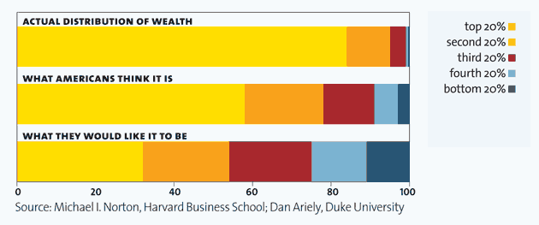**[Difference principle]** Social and economic inequalities are to be arranged so that they are both (a) to the greatest expected benefit of the least advantaged and (b) **[Fair opportunity rule]** attached to offices and positions open to all under conditions of fair equality of opportunity.

Rawls holds that the people in the original position would opt for a **liberal** society, in which each individual’s rights to pursue his or her own conception of the “good life” were protected by fundamental rights to speech, assembly, and religion. (Libertarians *agree* with Rawls about this.) He also holds that they would aim for a relatively **egalitarian** society, in which the position of the worst off would be maximized. Finally, he holds that they adopt a **fair opportunity rule** that ensured that no individual could be discriminated against unfairly (for example, while it *might* be OK to offer an “affirmative action” program in general terms, it would *not* be OK to offer jobs to only to specific individuals, without offering others a chance to compete.) Why does he think this?

Figure Liberal egalitarianism reflects a common intuition: that while things don't need to be *equal*, large inequalities are much harder to justify than smaller ones. From www.motherjones.com.

* Rawls believes that the rational agents in the original position will want to ensure that they have some ability to pursue their *own* sense of the good life, *even if this ends up being a sort of life that other people don’t like or approve of.* Because of this, they will avoid utilitarian principles, which can easily justify sacrificing minorities for the “greater good.” He argues that they will instead choose a package of **fundamental rights** that applies to everyone, including speech, religion, assembly, bodily privacy, and so on. These rights have *priority* over everything else, including the difference principle. For the same reasons, they will adopt a fair-opportunity rule to ensure that no one can discriminate against them based on morally irrelevant characteristics.
* **Primary goods** are “things that every rational man is presumed to want.” They include things like rights and opportunities (mentioned above) but also things like income and health. **Social primary goods** are things that society can help distribute (like income), while **natural primary goods** (like healthy genes) are currently out of society’s control. Rawls argues that these will be distributed according to the **difference principle,** which maximizes the position of the worst off. Why does he think this?
  + He assumes purely rational people will not be motivated by *envy,* so the mere fact of inequality won’t bother them. Rawls disagrees with Marxists, who think inequality is *inherently* bad.
  + Since the people in the original position are making a decision under *uncertainty* (that is, they don’t know *how likely* various outcomes are), he thinks they will focus primarily on making sure they don’t end up in an extremely bad situation, in which they would have no power to pursue their own goals. So, for example, they would choose the income distribution {1, 5, 6, 8} over the income distribution {-3, -2, 6, 20} even though the second has higher *average* income. He argues rational people will adopt the **maxi-min** rule (“maximize the value of the minimum position.”) It is related to (though not identical with) what economists call **risk aversion** (perfectly rational agents value avoiding losses more than they value accumulating gains).

## Answering the Anarchist: Nozick’s Entitlement Theory of Justice

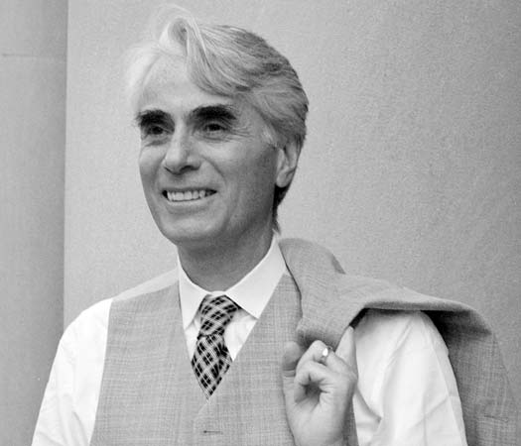**Robert Nozick** (1938 to 2002) was a colleague of John Rawls at Harvard. His book *Anarchy, State, and Utopia* was written directly in response to Rawls’ *A Theory of Justice,* and is considered one of the most important contemporary defenses of a **libertarian** theory of justice. Where Rawls thought that the government had a considerable role to play in the distribution of “primary goods” (and in particular thought that they should be distributed to help the worst off members of society), Nozick defended a **minimal state,** in which the government was responsible *only* for things like defense, policing, and assuring that children had a “fair chance.” The publication of his book in 1974 is considered one of the “founding moments” of contemporary libertarianism (which had been left for dead since the Great Depression.)

The debate between Rawls and Nozick is considered one of the most important debates in contemporary political philosophy. Rawls is often cited by advocates of so-called “social democracy” (this includes most of the left-wing parties in the US, Canada, Europe, and Australia), while Nozick is often cited by “libertarians” (who, along with religious conservatives, make up the bulk of the right-wing parties in these countries). It is important to remember, however, that both thinkers agree with “liberalism” (i.e., the idea that individuals have rights that governments must respect). So, they both would agree that things like Stalinist Communism or religious dictatorships are immoral.

### Nozick’s Two-Part Theory of Justice

According to Nozick, there is something fundamentally wrong with the idea that a just society is one in which things are “distributed” fairly. After all, this supposes that some entity (such as the government) has the moral right to do the “distributing.” Instead, Nozick thinks that a person’s owning (or “holding”) a certain good is justified if and only if certain conditions are met. He calls his theory the **entitlement theory of justice**, because it focuses on which holdings each person is “entitled” to.

1. A person might acquire a good that was previously unowned. In this case, he or she must abide by the **principle of justice in acquisitions.** While this is a tricky issue, Nozick thinks you can do this by adding your labor to some bit of previously unowned stuff (e.g., you built a cabin on an area of land that was previously unclaimed by anyone). In this case, the person must obey the **Lockean proviso,** which says that you must leave “as much and as good for others.” A person would be violating the Lockean proviso by, for example, claiming that he gets *all* the available land because “he got there first.” This wouldn’t be fair to people who arrived *later* (for example, to later immigrants, or to future generations)*.* A just society *must* allow a “fair chance” for new arrivals.
   1. People often model the Lockean proviso as a “deserted island” case. If you get to the island first (and you understand that other people will eventually be coming), you obviously have a right to use some stuff (so, you can build yourself a hut, and gather coconuts), but you can’t take *all* of the stuff. Similarly, when other people arrive, they have a right to use some of the land, but they obviously can’t take over your hut (which you built) or take your coconuts.
   2. The Lockean proviso forbids anyone owning a *monopoly* on naturally occurring goods (such as water or oil), or on goods that would eventually have been invented by someone other than the original inventor (so, for example, it would forbid a drug company from taking out a 1,000-year long patent on some life-saving medication).
2. A person might acquire a good previously owned by *someone else.* In this case, he or she must abide by the **principle of justice in transfers.** So, for example, suppose a farmer grows some wheat (which she owns), and she sells this to a baker, who then bakes a loaf of bread. You could then acquire this *justly* from the baker by paying whatever price he would accept. It would NOT be just for you take it by force or to steal it.

We also need a final principle, called the **principle of rectification**, which determines what we should do when somebody *violates* the first two principles. For example, what happens if (1) you arrive at an island and the people tell you “we got here first; so, you can’t have any food or water” or (2) you buy a coconut from someone, but are approached by someone who gives you evidence that she is the *real* owner of the coconut (and the person who sold it to you had stolen it from her). In this case, the government will step in.

In Nozick’s ideal libertarian society, the “state” (or government) exists exclusively to make sure these three principles are enforced. This means, for example, that the government will provide services for new members of society (mostly children, but also immigrants or refugees), enforce business contracts, and make sure that injustices are rectified. Meeting the Lockean proviso will also requires a certain amount of public infrastructure (perhaps including roads, hospitals, sewer systems, and so on) that allow people a “fair chance” to obtain employment through the free market.

## What’s Wrong with Patterns? The Wilt Chamberlain Objection

Nozick argues that Rawls’s theory of justice is a “patterned” theory of justice. That is, Rawls’ theory defines *justice* as a certain sort of *distribution* (in particular, it is a distribution that hands out fundamental rights evenly, and then maximizes the position of the worst of members of society). Many theories of justice are like this—for example, a Marxist theory of justice might call for a *completely* equal distribution of primary goods (without concern for basic rights, or even for maximizing the position of the worst off). Nozick gives his famous **Wilt Chamberlain** example in an effort to show that all such theories of justice are flawed:

*It is not clear how those holding alternative conceptions of distributive justice can reject the entitlement conception of justice in holdings. For suppose a distribution favored by one of these non-entitlement conceptions is realized. Let us suppose it is your favorite one and let us call this distribution D1; perhaps everyone has an equal share, perhaps shares vary in accordance with some dimension you treasure. Now suppose that Wilt Chamberlain is greatly in demand by basketball teams, being a great gate attraction…He signs the following sort of contract with a team: In each home game, twenty-five cents from the price of each ticket of admission goes to him….The season starts, and people cheerfully attend his team's games; they buy their tickets, each time dropping a separate twenty-five cents of their admission price into a special box with Chamberlain's name on it. They are excited about seeing him play; it is worth the total admission price to them. Let us suppose that in one season one million persons attend his home games, and Wilt Chamberlain winds up with $250,000, a much larger sum than the average income and larger even than anyone else has. Is he entitled to this income? Is this new distribution D2, unjust? If so, why? There is no question about whether each of the people was entitled to the control over the resources they held in D,; because that was the distribution (your favorite) that (for the purposes of argument) we assumed was acceptable. Each of these persons chose to give twenty-five cents of their money to Chamberlain. They could have spent it on going to the movies, or on candy bars, or on copies of Dissent magazine, or of Monthly Review But they all, at least one million of them, converged on giving it to Wilt Chamberlain in exchange for watching him play basketball. If D, was a just distribution, and people voluntarily moved from it to D2, transferring parts of their shares they were given under D, (what was it for if not to do something with?), isn't D, also just? If the people were entitled to dispose of the resources to which they were entitled (under D,), didn't this include their being entitled to give it to, or exchange it with, Wilt Chamberlain? Can anyone else complain on grounds of justice?*

Nozick’s idea here is basically this: According to Rawls, it is *unjust* for Wilt Chamberlain to have all of this money. But Nozick thinks this is crazy: after all, we started with a distribution that Rawls *did* think was just, and simply let people make *voluntary choices.* The inequality we see at the end was the result of these free choices. So, where a left-wing Rawlsian state would tax Chamberlain more than other citizens, a libertarian Nozickian state would not.

Nozick offers a more general argument that *any* taxation (beyond that which was required for basic policing and defense, and for meeting the Lockean proviso) is a form of *slavery.* The structure of his argument can be represented as follows:

1. Suppose that tax system T is a *progressive* tax system, where a person pays NO tax on the money they need to live. For example, let’s suppose that the first $300 you earn each week are tax free. After this, however, you pay 50% for each *additional* dollar you make. For simplicity, let’s suppose you make $10/hr. This means you make enough to live off in 30 hrs/week. If you work more than this, you would earn $5/hr and the government would get $5/hr (in taxes).
2. Nozick argues that this is equivalent to a system that (a) allows people to choose between living at “subsistence levels” OR (b) choosing to work more AND being forced to serve at forced labor camps for the “common good.” So, in the example above, if you chose to work five hours of (tax-free) overtime, the government would forcibly make you serve in a labor camp for five hours (for which you would be paid nothing).
3. Nozick thinks this is an *arbitrary* discrimination against people whose tastes and values require the acquisition of material goods. For example, a singer can perform his task with little extra stuff (so, he wouldn’t be forced into extra labor in order to help the violinist), but the violinist (who needs access to an expensive instrument) would end up having to work for the singer (since her extra wages would be subject to progressive taxation).
4. This would imply, for example, that taxing Wilt Chamberlain’s extra income in the example above would be a form of a “forced labor,” or “slavery” since *he* is forced to devote a portion of his time working for the good of his audience but *they* are not forced to work on his behalf.

Nozick concludes that a Rawlsian state which aims to meet the “difference principle” (and redistribute primary goods to help the worst off) will inevitably violate people’s fundamental rights.

## Libertarianism and the Rectification Problem

Where a liberal egalitarian government must be “future looking,” in the sense that its goal is to help out the people who are *currently* worst off, without being *too* concerned about how they got there. In contrast, a libertarian government must be “backward-looking” in that it must make sure to rectify all *past* violations of property rights, no matter how bad the *present effects* of this rectification might be. Libertarians (by the very nature of their theory) can’t say something like “that all happened a long time ago, so it doesn’t matter now.”

This raises an immediate problem, however. After all, there are large income disparities between non-Hispanic whites and African Americans and Native Americans (and between the poor and rich more generally). There is good reason to think these current disparities are due, at least in part, to past violations of property rights (slavery, war, etc.). However, it is almost impossible to provide any sort accurate *measure* of how much each individual person currently living was hurt by (or benefitted from) these past injustices. To solve this, Nozick suggests that a truly libertarian government might resolve this problem by doing a once-off “redistribution” of income to level the playing field and rectify past injustices (i.e., we throw everyone’s possessions into a big pot, and give everyone a fair share). After this, there should be no further of redistribution of income. Lots of people have argued that isn’t politically realistic (since it involves completely disrupting society); however, it is tough to see how Nozick can avoid it.

## Review Questions

1. In your own words, explain the basic structure of Rawlsian liberal egalitarianism. How do basic rights fit in? The difference principle? And what role do things the “original position”, “veil of ignorance”, and “maxi-min” principle play in Rawls’ argument?
2. What are Nozick’s basic *criticisms* of Rawls’ position? What exactly is the Wilt Chamberlain argument supposed to show? Do you think it works?
3. Nozick recognizes that *current* distributions of property likely involved (at some point in the past) a variety of injustices: slavery, sexism, war, theft, and so on. In response to this, he proposes that society do a “once-off” redistribution of stuff in order to start with a clean state. Why do you think Nozick proposes this (hint: it has to do with his entitlement theory of justice)? Why might this be *less* of a problem for Rawlsian liberals?
4. Whose view do you find more plausible: Rawls or Nozick? Why?